|  |  |
| --- | --- |
|  | **Computer Organization & Assembly Language**  **BSCS-3**  **Department of Computer Science**  **Bahria University, Lahore Campus** |

**Assignment: [3]**

Date: Week 11, 20th May 2023

Name: Muhammad Ahsan Roll No: 03-134221-018

|  |  |  |  |
| --- | --- | --- | --- |
| **Evaluation of CLO** | **Question Number** | **Marks** | **Obtained Marks** |
| **CLO3:** | 1 | 10 |  |
|  |  |  |
|  |  |  |
|  |  |  |
| **Total Marks** | | **10** |  |

**Question 1: [Marks: 10]**

**Project Proposal**

**Must follow these guide line**

* **Previous work**
  + - ***Cash Withdrawal***
      * + Allows the withdrawal of cash from the atm machine
    - ***Change MPIN***
      * + Allows to change the Mpin of the account
    - ***Check Balance***
      * + Allows to check the current balance in the account
    - ***Cash Transfer***
      * + Allows the transfer of cash between accounts
    - ***Mini Statement***
      * + Prints a mini statement stating the last 5 transactions
    - ***Utility Bills***
      * + Allows to pay utility bills through atm
    - ***Information***
      * + Allows to see information on any function in the atm
* **New work** 
  + - ***Loan***
      * + Allows to take a loan under certain conditions
    - ***Wire Transfer***
      * + Allows to transfer of cash inter-countries
    - ***Upgrade Account***
      * + Upgrading of account from standard to gold and silver
    - ***Cash Deposit***
      * + Allows the deposit of cash through atm
    - ***Order Cheque Book***
      * + Allows the ordering of cheque book through atm
* **Benefit of your project**
  + - Provide convenience to customers.
    - Offer 24/7 service.
    - Reduce banks workload.
    - Access the bank account from anywhere.
    - Minimize transactions cost.
    - Self-service counters.
    - Do not require an extensive workforce.
    - Provided the number of locations.
    - Others banks can also be used.
    - Maximum security.
    - ATM is very beneficial for travelers.
    - ATM may give customers new currency notes.
    - Provide privacy in banking transactions.
* **Use case diagram**

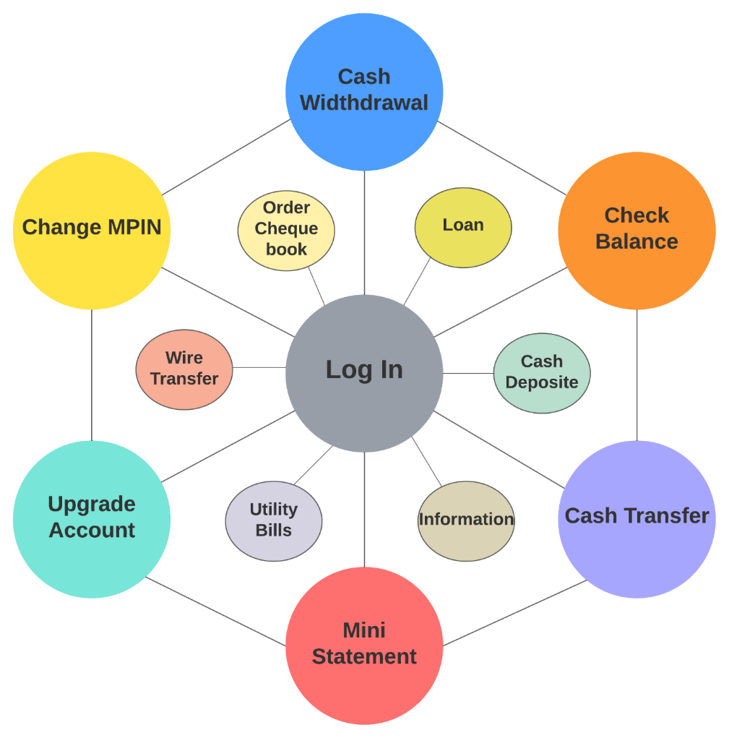

* **Conclusion**

ATM System will be the premier software to be chosen by ban to receive money from around the country in just a few minutes. It will be package of software applications for everyone that combine grace, simplicity and ease of use with the powerful and robust feature set most requested by experts.

Following are the few outlines of the solutions that ATM system intended to provide.

• It will be easy to configure and personalize the complete control.

• It will offer a variety of different form of transaction

**Proposal should not be more than 3 pages and not less than 2 pages.**

**Note: If someone want to do work with hardware implementation they can do it.**